**1] Java Inheritance** is a mechanism in which one class acquires the property of another class.

2] In Java, when an "Is-A" relationship exists between two classes, we use Inheritance.

3] The parent class is called a super class and the inherited class is called a subclass.

4] The keyword extends is used by the sub class to inherit the features of super class.

5] There can be three types of inheritance in java: single, multilevel and hierarchical.

6] In java programming, multiple and hybrid inheritance is supported through interface only.

**Single Inheritance:** In Single Inheritance one class extends another class (one class only).

[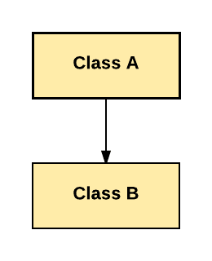](https://cdn.guru99.com/images/java/single_inheritance.png)

In above diagram, Class B extends only Class A. Class A is a super class and Class B is a Sub-class.

**Multiple Inheritance:** Multiple Inheritance is one of the inheritance in Java types where one class extending more than one class. Java does not support multiple inheritance.

[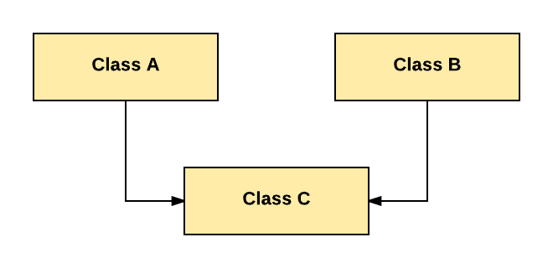](https://cdn.guru99.com/images/java/multiple.png)

As per above diagram, Class C extends Class A and Class B both.

**Multilevel Inheritance:** In Multilevel Inheritance, one class can inherit from a derived class. Hence, the derived class becomes the base class for the new class.

[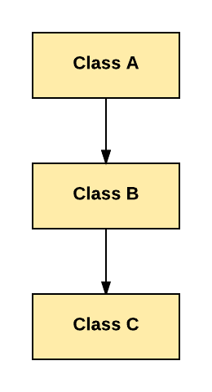](https://cdn.guru99.com/images/java/multilevel.png)

As per shown in diagram Class C is subclass of B and B is a of subclass Class A.

**Hierarchical Inheritance:** In Hierarchical Inheritance, one class is inherited by many sub classes.

[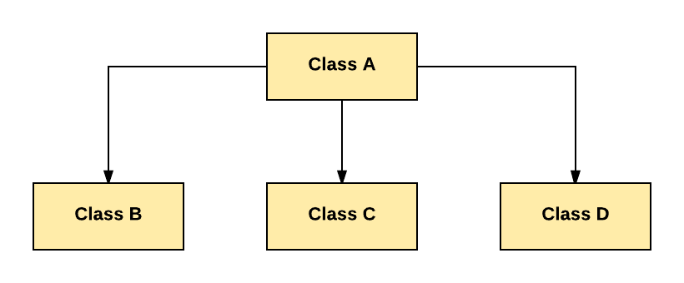](https://cdn.guru99.com/images/java/hierarchy.png)

As per above example, Class B, C, and D inherit the same class A.

**Hybrid Inheritance:** Hybrid inheritance is one of the inheritance types in Java which is a combination of Single and Multiple inheritance.

[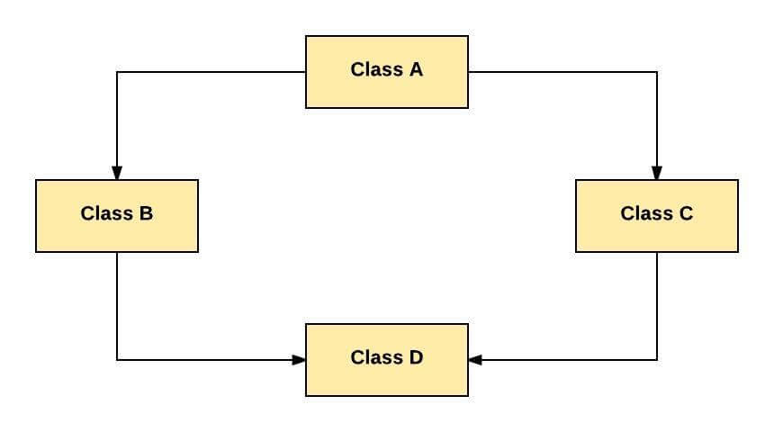](https://cdn.guru99.com/images/java/hybrid.jpeg)

As per above example, all the public and protected members of Class A are inherited into Class D, first via Class B and secondly via Class C.